Exercise 2
Typescript - User Registration & Login System

Objective
Develop a User Registration & Login System using TypeScript. The application should allow users to register, log in, view registered users, and exit the program through a menu-driven interface.

Main Menu
*************** USER MANAGEMENT SYSTEM ***************
1. Register
2. Login
3. View Users
4. Exit

Requirements
Register
- Choose Register to create a new user account.
- Collect the following details:
  - First Name
  - Last Name
  - Email
  - Phone Number
  - Username
  - Password
- Validate the following:
  - Email must be unique.
  - Password must contain at least 8 characters.
- If registration is successful, display:
Registration Successful
- If the email already exists, display:
Email already exists
- If the password is less than 8 characters, display:
Password must contain minimum 8 characters

Login
- Choose Login from the main menu.
- Ask the user to enter:
  - Username
  - Password
- Validate the entered credentials.
- If the username and password match an existing user, display:
Login Successful
- Otherwise, display:
Invalid Credentials

View Users
- Choose View Users to display all registered users.
- Display the following details for each user:
  - Full Name
  - Email
  - Phone Number
  - Username
- If no users are registered, display:
No Users Found

Exit
- Choose Exit to terminate the application.
- Display:
Thank You...

Constraints
Implement the application using:
- TypeScript
- Interface
- Class
- Arrays
- Functions
- Switch-case
- if-else statements
- Menu-driven program
- Console input using readline

Expected Output
Example 1 – Registration
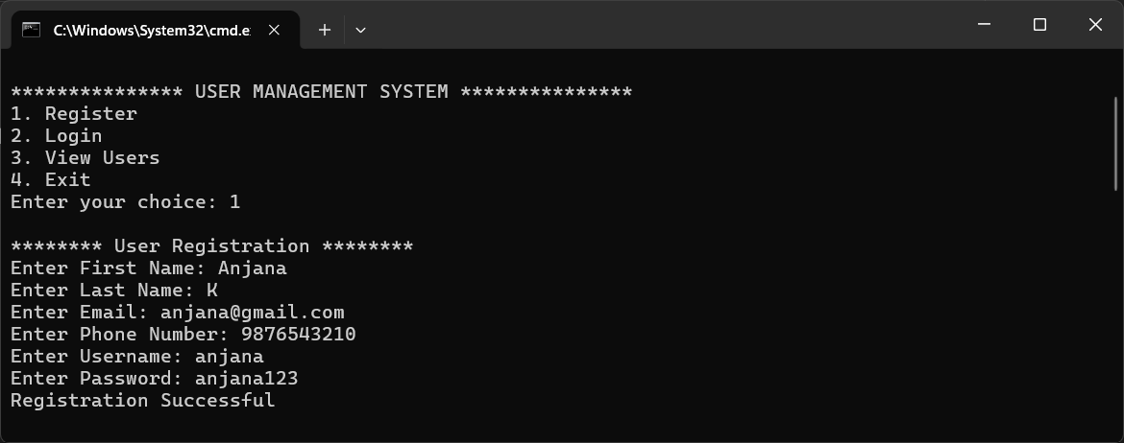

Example 2 – Duplicate Email
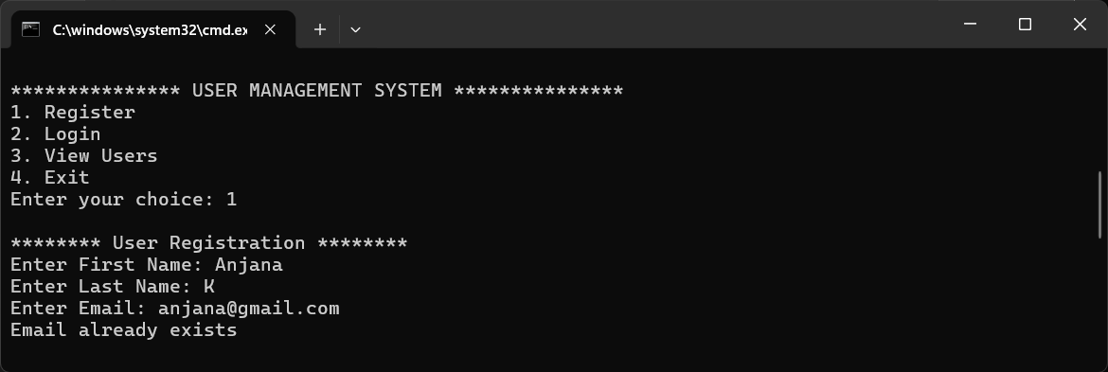

Example 3 – Invalid Password
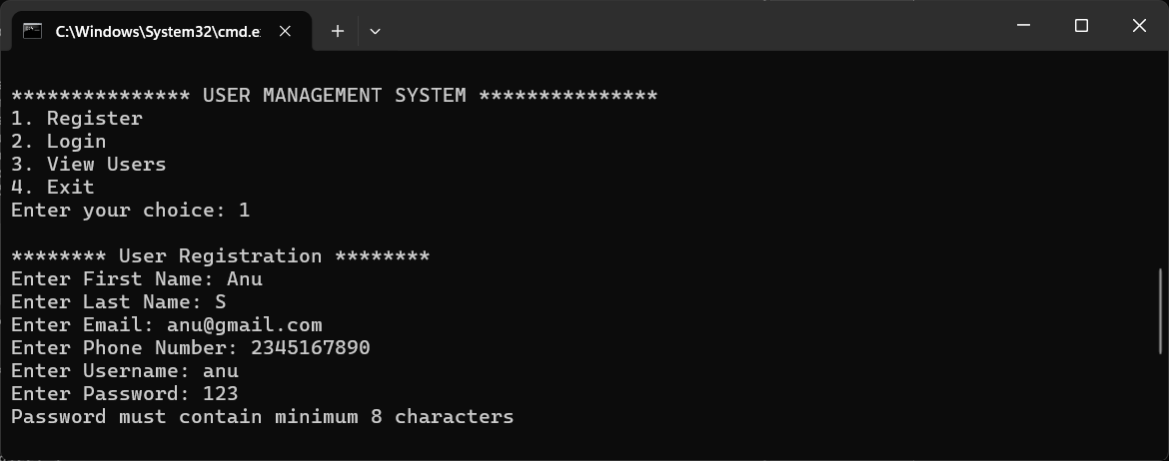

Example 4 – Login
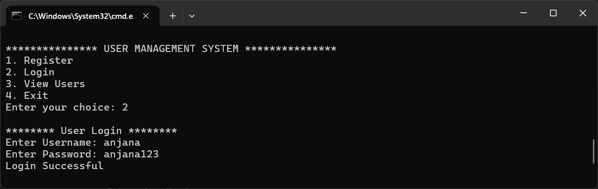

Example 5 – Invalid Login
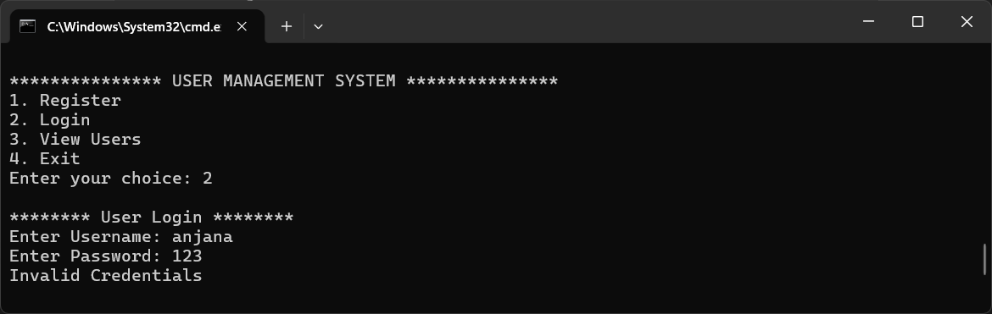

Example 6 – View Users
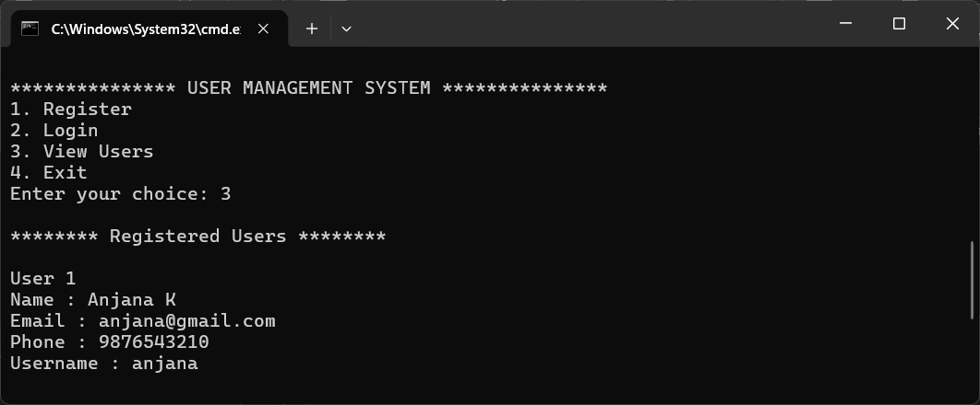

Example 7 – No Users Found
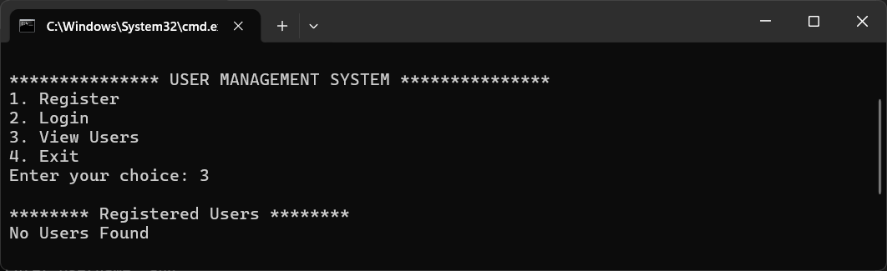

Example 8 – Exit
